Helpful Ergonomic Tips for Working from Home

If you’re working from home during the COVID-19 pandemic, you might find that your makeshift office is not comfortable. Remember, this is only a temporary situation. The information below will assist you in being pro-active and conscientious of your posture and routine so you can combat the stress and strain that might come from working in a compromised position.
Working for extended periods of time at your kitchen counter or hunched over a coffee table? Below are some cheap and creative ways to trick out your temporary home set-up to make it more ergonomic and comfortable to work at.
- Change Your Position Often:
For example, you might start your day at your kitchen table, then transition to a standing position or sit on your soft couch. It’s best to alternate every hour.
- Pillow on your Seat:
Placing a thin pillow underneath your seat can go a long way to making an ordinary chair a lot more comfortable and will help bring you higher in the seat if needed. If you don’t have a pillow, you could also fold up a fluffy towel for the same effect.
Chair has you sitting higher with the pillow and it does not adjust causing our feet to dangle? Place books or a box under your feet to allow your knees and hips to be at a 90-degree angle.
Draping a soft towel over the back of your chair can take away the space from your upper back and the chair allowing support.
- Need Lumbar Support: You don’t need to buy a fancy pillow to accomplish this effect; rolling a towel or placing a paper towel roll between your chair and lowerback provides lumbar support.
(See photo below)
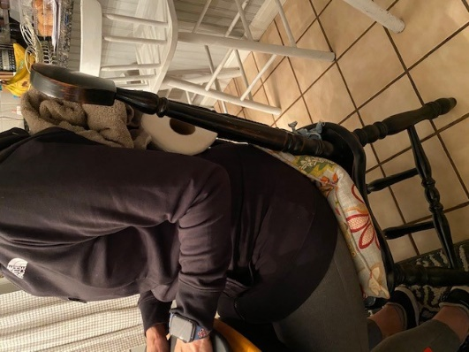
Pillow on seat
Rolled up towel
Paper towel roll
- Try your Feet up:
Supporting your feet on an elevated surface, or stretching your legs long increases circulation and can feel nice.
Ideally, your hips and thighs should form 90-degree angles when you sit in your chair, but you can move your feet back and forth for exercise.
Laptops are never going to be ergonomically good, because the monitor is either going to be too low or the keyboard is going to be too high.
Ideally, the top of your monitor should be just below eye level, so you don’t have to strain your neck to read. If you’re working on a reading-intensive task, prop your laptop up on objects (like a stack of books or shoeboxes) so it’s eye-level. Then, when you need to type, you can lower it to a level that allows your arms to be bent at 90-degree angles.
- Monitor height for normal vision and those with Bifocals/Progressive Eyeglasses:
If you have normal vision or you wear bi-focal or progressive lenses, your monitor should be at or below eye level, so your head is not tilting up to read the text on your monitor. If it does not adjust or your chair does not adjust, and you need to get higher up, follow steps in #2 above.
- Keyboard and Mouse:
- Your keyboard should be at your elbow height on a solid surface
- If possible use an external keyboard and mouse to mimic in office set ups
- Your mouse should be directly next to the keyboard on the same level

- Excessive background lighting:
Can create contrast problems on your screen, causing you to strain your eyes to see your work. Possible solutions for this include:
- Moving your computer or workstation so the sources of the bright lights, such as uncovered windows, are at right angles of your computer screen.
- Blinds or drapes on windows help eliminate the bright light.
- Reflected light from overhead lights or polished surfaces, such as keyboards and walls, can cause glare and limit your ability to see your screen adequately. Some possible solutions for this glare problem include: tilting down the monitor to prevent it from reflecting overhead light.

- Noise control:
Too much noise and disturbance can cause undue stress and irritation which makes it difficult for to concentrate on the work to be done.
- A good solution to reducing noise is to use earplugs, which is a simple, cost-effective and convenient solution!
- Take Breaks:
Set a timer to go off every 30 minutes to take a micro-break of about 30-60 seconds. for Get up and walk around or do some quick static or dynamic stretches and add exercise too! There are many good 7-10-minute workout APPS!
- Hydrate:
Be sure to drink lots of water and stay hydrated……it is easy to have caffeine at your finger-tips, but remember, caffeine dehydrates you.

Note: Per Commissioner VanNote’s e-mail dated, 3/18/2020, if your desktop option is approved,

- Hardware to be removed is limited to the desktop computer, monitor, keyboard, and mouse. Other than the desktop computer, you may also use equipment that you already have at home (monitor, keyboard, mouse).
- A complete and accurate list of all state hardware being removed must be provided to your supervisor before it is removed from state property. Supervisors will keep an inventory of any and all hardware removed on a department wide SharePoint document.
Questions? Contact: Janice Arsenault, Director, Health & Wellness
Janice.arsenault@maine.gov or (207)592-5598
